**23/07/2021**

Generic Process Framework

Phases of Generic Process Framework

1. Definition Phase
2. Development Phase
3. Support Phase: Preventive Maintenance, Adaptive Maintenance, Enhancive Maintenance, Perfective Maintenance

Steps of Generic Process Framework

1. Communication
2. Planning
3. Analysis Modelling
4. Design Modelling
5. Construction
6. Deployment

Software Engineering Layers – Process Layer

Definitions

1. An Activity refers to achieve a broad objective.
2. An Action encompasses a set of tasks that produce a major work product.
3. A Task focuses on a small, but well-defined objective that produces a tangible income.

Tools

1. Software engineering tools provide automated or semi-automated support for the process and the methods.
2. Examples: Microsoft front page or Microsoft Publisher as web designing Tool. Rational Rose can be used for as object-oriented analysis and design tool.

Software Process Framework

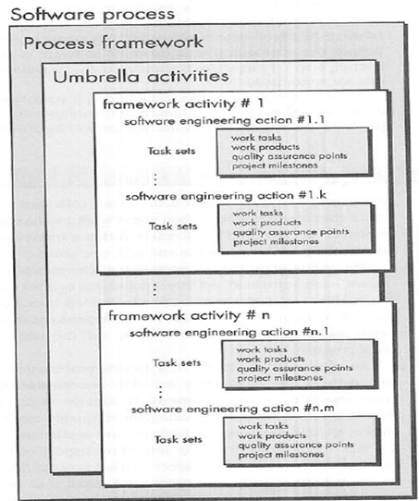

Umbrella Activities

1. To help software team to manage and control progress, quality, change and risk.
2. Activities include:
3. SQA: Software Quality Assurance
4. Project Scheduling and Tracking
5. Risk Management
6. SCM: Software Configuration Management
7. Technical Reviews
8. Reusability Management
9. Measurement- Defines and Collects process, project and product measures that assists the team in delivering software.

Prescriptive Process Model

Models

1. Waterfall Model
2. Incremental Process Models
3. Incremental Model
4. RAD Model
5. Evolutionary Process Models
6. Prototyping
7. The Spiral Model
8. The Concurrent Development Model
9. Specialized Process Models
10. Component Based Development
11. The Formal Method Model
12. Aspect-Oriented Software Development

Set of Framework Activities

1. Communication
2. Planning
3. Modelling
4. Construction
5. Deployment

**27/07/2021**

Waterfall Model

Introduction

* Waterfall model aka Class Life Cycle or Linear Sequential Model.
* Systematic, sequential approach to software development that begins with customer specification of requirements and progresses through planning, modeling, construction and deployment.

Modelling

* It includes detail requirement analysis and project design
* Flowchart shows complete pictorial flow of program whereas algorithm is step by step solution of problem

Construction

* It includes coding and testing phases
* Coding- Design details are implemented using appropriate programming language
* Testing- It is carried out to check whether flow of coding is correct, to check out the errors of program.

Steps

**Step 1:**

Requirement Analysis

**Step 2:**

System Design

**Step** **3:**

Implementation

**Step 4:**

Testing

**Step 5:**

Deployment

**Step 6:**

Maintenance

FAST

Facilitated Application Specification Technique

QFD

Quality Function Deployment

1. **Normal Requirements**

These requirements reflect objectives and goals stated for a product or system during meetings with the customer.

1. **Expected Requirements**

These requirements are implicit to the product or system and may be so fundamental that the customer does not explicitly state them.

1. **Exciting Requirements**

These requirements reflect features that go beyond the customer’s expectations and prove to be very satisfying when present.

**28/07/2021**

Incremental Model

Introduction

* It combines the elements of the waterfall model applied in an interactive fashion.
* Each linear sequence produces deliverable increments of the software.

RAD Model

Introduction

* Rapid Application Development is when a business application can be modularized in a way that enables each major function to be completed in less than three months.
* Each major function can be addressed by a separate RAD team and then integrated to form a whole.

Four Teams in RAD

* Communication – Works to understand the business problem and the information characteristics that the software must accommodate.
* Planning – Essential because multiple software teams work in parallel on different system function.
* Modeling – 3 major phases – business modeling, data modeling and process modeling.

1. Business Modeling – Includes information flow among different functions in the project
2. Data Modeling – Includes different data objects used in software and relationship among different objects.
3. Process Modeling – During process modeling, process descriptions are created.

Merits/Advantage

* A product can be developed within a very short period of time.
* Increased reusability of the components.
* Minimal code writing as it supports automatic code generation.
* Encourages customer feedback.
* Quick initial reviews are possible.
* Module integration is done from the beginning thus resolving number of integration issues.

Drawbacks

* For large but scalable projects RAD require sufficient human resources to create the right number of RAD teams
* If developers and customers are not committed to the rapid-fire activities necessary to complete the system in a much abbreviate time frame, RAD projects will fail.
* If a system cannot be properly modularized, building the components necessary for RAD will be problematic.
* RAD may not be appropriate when technical risks are high.